PUBLIC TRANSPORTATION EFFICIENCY ANALYSIS

Project Definition: The efficiency of transport systems is determined by a data envelopment analysis – DEA. Urban transport systems are considered decision making units – DMUs that relatively measured in relation to those that determine the efficiency frontier. There are two major approaches – a parametric and a non-parametric one.
Project Objective:
As a subsidy to its change an efficiency analysis is done with the purpose of highlighting characteristics of the efficient systems. Twelve transport system from several countries in Europe and seven from Brazil are analyzed: nine from Europe and only one from Brazil were found efficient.24-Feb-2019
Data Collection: The efficient transport systems are quite necessary in the cities to support the economy and thewelfare of the city population. The main focus is currently placed not so much on the construction of newobjects of transport infrastructure, but mostly on the efficient use of the existing ones. Therefore, thedevelopment of a high-quality urban public transport system meeting the requirements of tenants is a keyconcern of the city development. To estimate UPTS quality, a quality rating system should be developed and continuous monitoring of service quality should be exercised.
Data Preparation: The application of advanced communication, electronics and information technologies for improving the efficiency, safety, and reliability of transportation systems is commonly referred to as Intelligent Transportation Systems (ITS). ITS have enabled the automated collection of transportation data and their efficient transmission, allowing for better, more informed decisions, primarily in “real-time” operations.
Data Visualization with IBM Cognos: Use IBM Cognos or a similar data visualization tool to create visualizations and dashboards that provide insights into user behavior, popular pages, and traffic sources. Generate charts, graphs, and reports that make it easy for stakeholders to interpret and derive insights from the data.
Advanced Analysis with Python: Data Analysis is the technique of collecting, transforming, and organizing data to make future predictions and informed data-driven decisions. It also helps to find possible solutions for a business problem.
Insights and Recommendations: Analyze the results from both the davisualization tool and your Python-based analysis to derive actionable insightsBased on these insights, provide recommendations to the website owners for improving the user experience. These recommendations should be data-driven and tailored to the specific findings.
Implementation and Monitoring: Work with website owners to implement the recommended changes or enhancements to the website. Continuously monitor the impact of these changes on user behavior and website performance.
Documentation and Reporting: Document your analysis process, findings, and recommendations in a clear and concise manner. Create reports and presentations that can be shared with stakeholders.
Iterate and Improve: Website analytics is an ongoing process. Regularly update your analysis as new data becomes available and refine your recommendations based on evolving user behavior and trends.
Throughout the project, it's essential to maintain data privacy and security, adhere to relevant regulations , and ensure that sensitive user information is handled responsibly. Additionally, effective communication with stakeholders is critical to ensure that the analysis results in meaningful improvements to the website's user experience
Data Source:
https://www.kaggle.com/code/shubamsumbria/traffic-violations-exploratory-data-analysis
VISUALATION IS USING IBM COGNOS ANALYTICS :

1.Stop_duration by stop_outcome

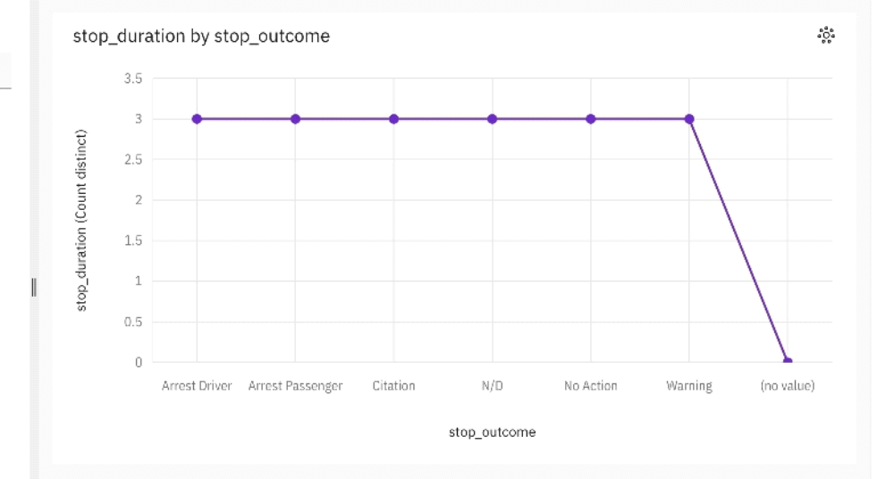

2.Stop_time by stop_date

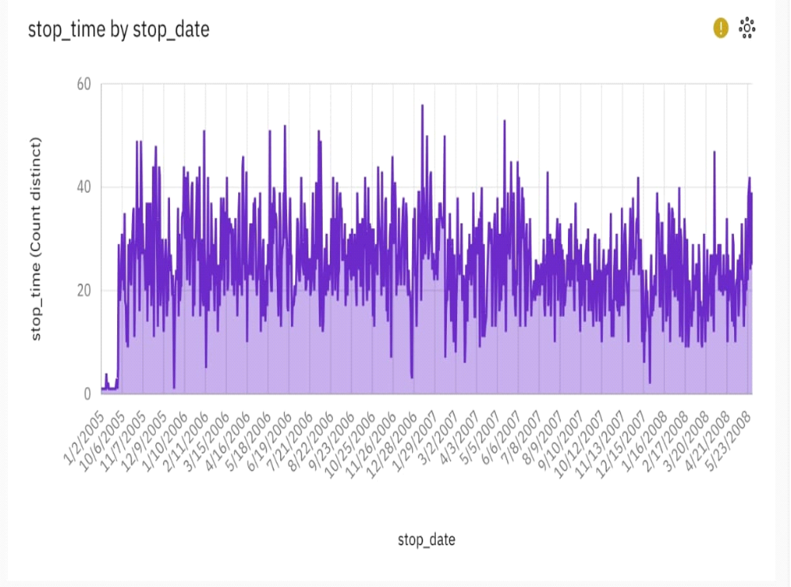

3.Driver_age_raw by driver_race

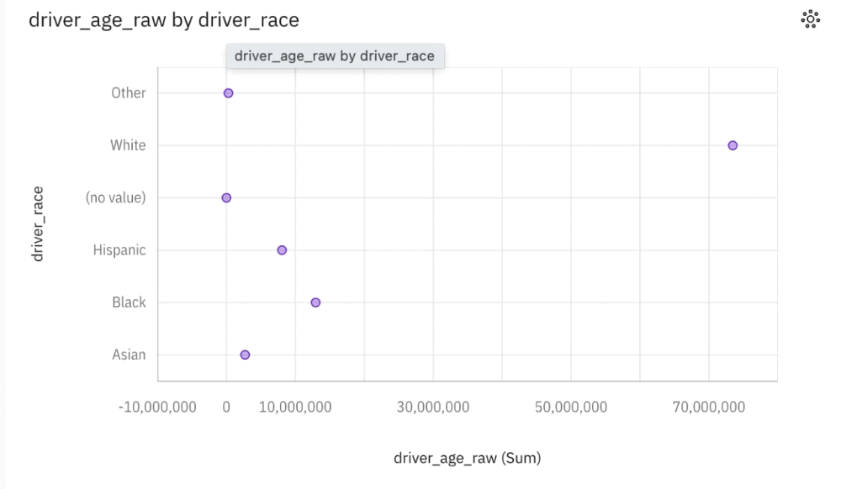

4.Stop_duration by search_conducted

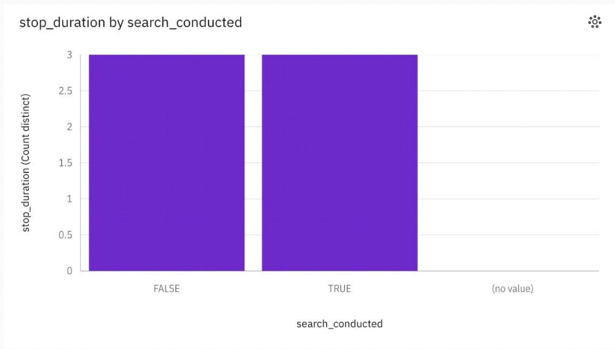

CONCLUSION :
The comprehensive analysis of the public transportation system reveals several key areas of strengths and potential improvements. The data indicates that the implementation of technology-driven solutions, such as real-time tracking and digital ticketing, has significantly enhanced the overall efficiency and user experience.

